Name: | ________________________________________ | Date Due: ___________
 | Year 10 Mathematics  Investigation 2, 2015  Topic – Linear Functions  Take home component
AIM: In this assessment, you will be investigating parallel and perpendicular linear functions.
Please note: The take home component will be required for the in class component of this investigation.
The take home component will be worth 10 bonus marks on your in class component. If you do not hand in your take home component, you will not be rewarded with these bonus marks.

1. | Give definitions for the following words:
a) | parallel
b) | perpendicular
c) | gradient
d) | linear function
e) | equation
f) | y-intercept

2. | For each equation given below, complete the table of values and graph the functions on the axes below.
a) | 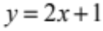 | b) | 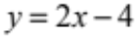
  x | –2 | –1 | 0 | 1 | 2
  y
  x | –2 | –1 | 0 | 1 | 2
  y
c) | 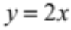 | d) | 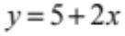
  x | –2 | –1 | 0 | 1 | 2
  y
  x | –2 | –1 | 0 | 1 | 2
  y

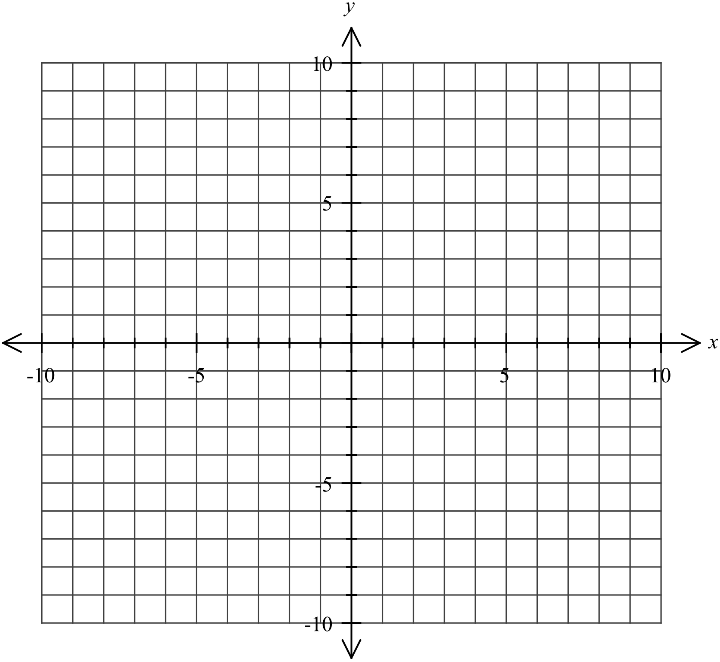
3. | What do you notice about the graphs? What is this relationship called?

4. | The following axis has graphs drawn on them already. For each graph, complete the table below, stating the gradient, y-intercept and the equation of the linear function.

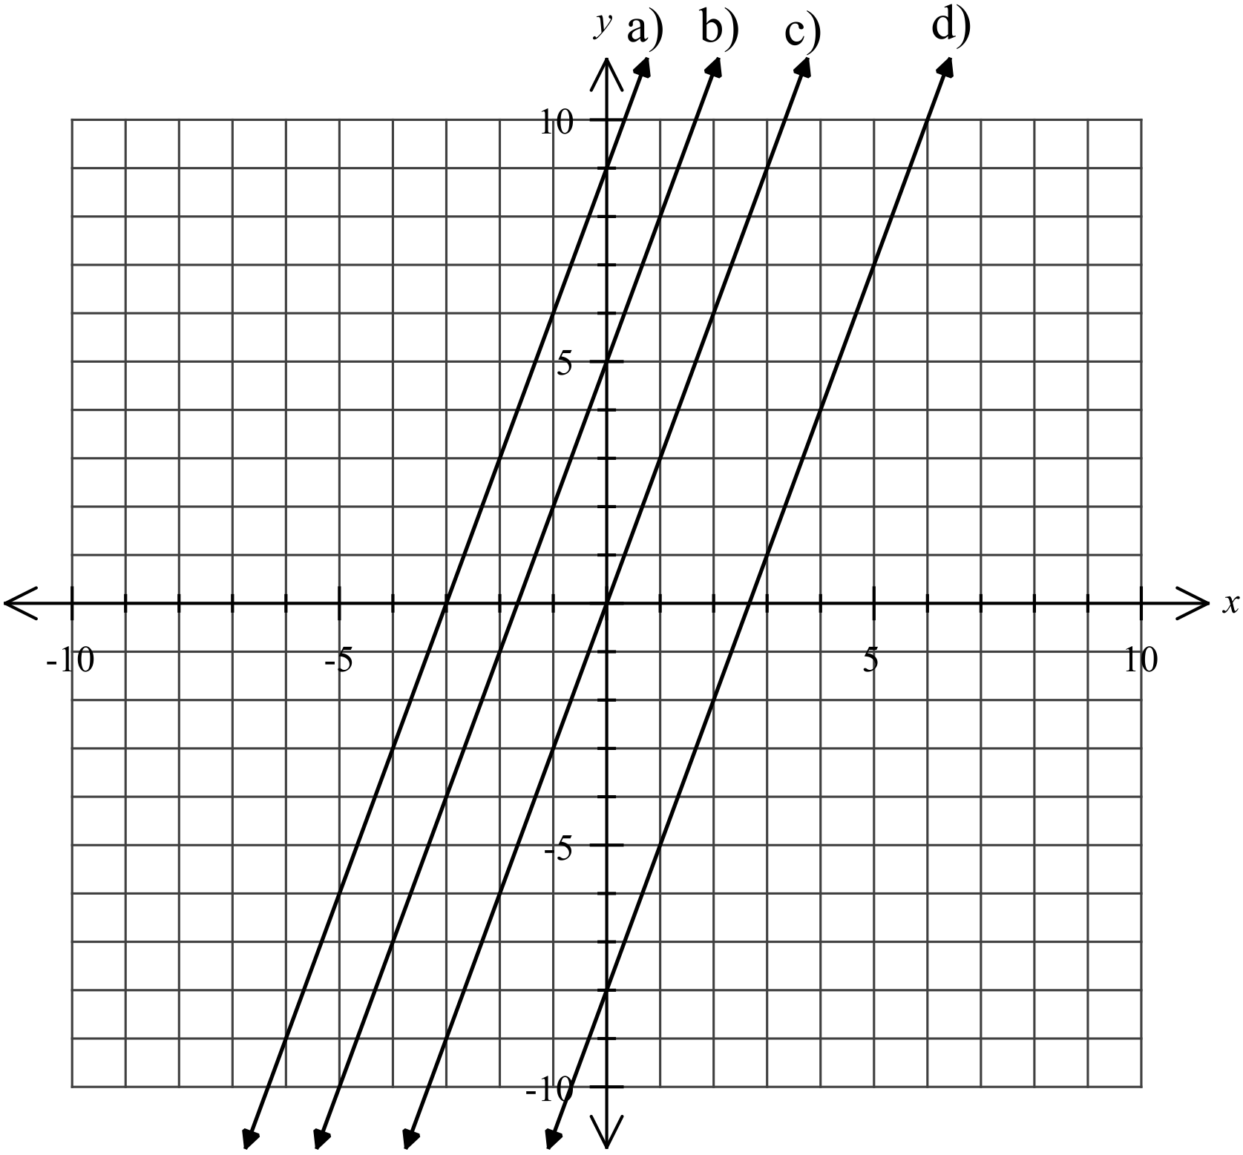

 | Gradient | y-intercept | Equation
a)
b)
c)
d)

5. | What pattern do you notice about the gradients of these lines? What is this relationship called?

6. | Write a conjecture (guess) about the connection between the gradients of any lines that are parallel.

7. | Use your conjecture to state whether each pair of linear functions below are parallel:
a) | 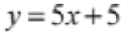 and 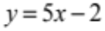
b) | 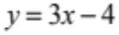 and 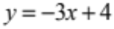
c) | 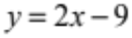 and 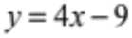
d) | 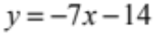 and 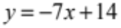

8. | For each equation given below, complete the table of values and graph the functions on the axes below.
a) | 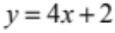 | b) | 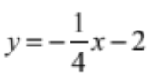
  x | –2 | –1 | 0 | 1 | 2
  y
  x | –4 | –2 | 0 | 2 | 4
  y

9. | Measure the angle between the two graphs. What do you notice? What is this relationship called?

10. | For each equation given below, complete the table of values and graph the functions on the axes below.
a) | 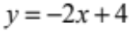 | b) | 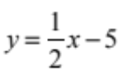
  x | –2 | –1 | 0 | 1 | 2
  y
  x | –4 | –2 | 0 | 2 | 4
  y

11. | Measure the angle between the two graphs. What do you notice? What is this relationship called?

12. | Each graph below contains pairs of lines. Calculate the gradient of each line and record the results in the table below.
a) | 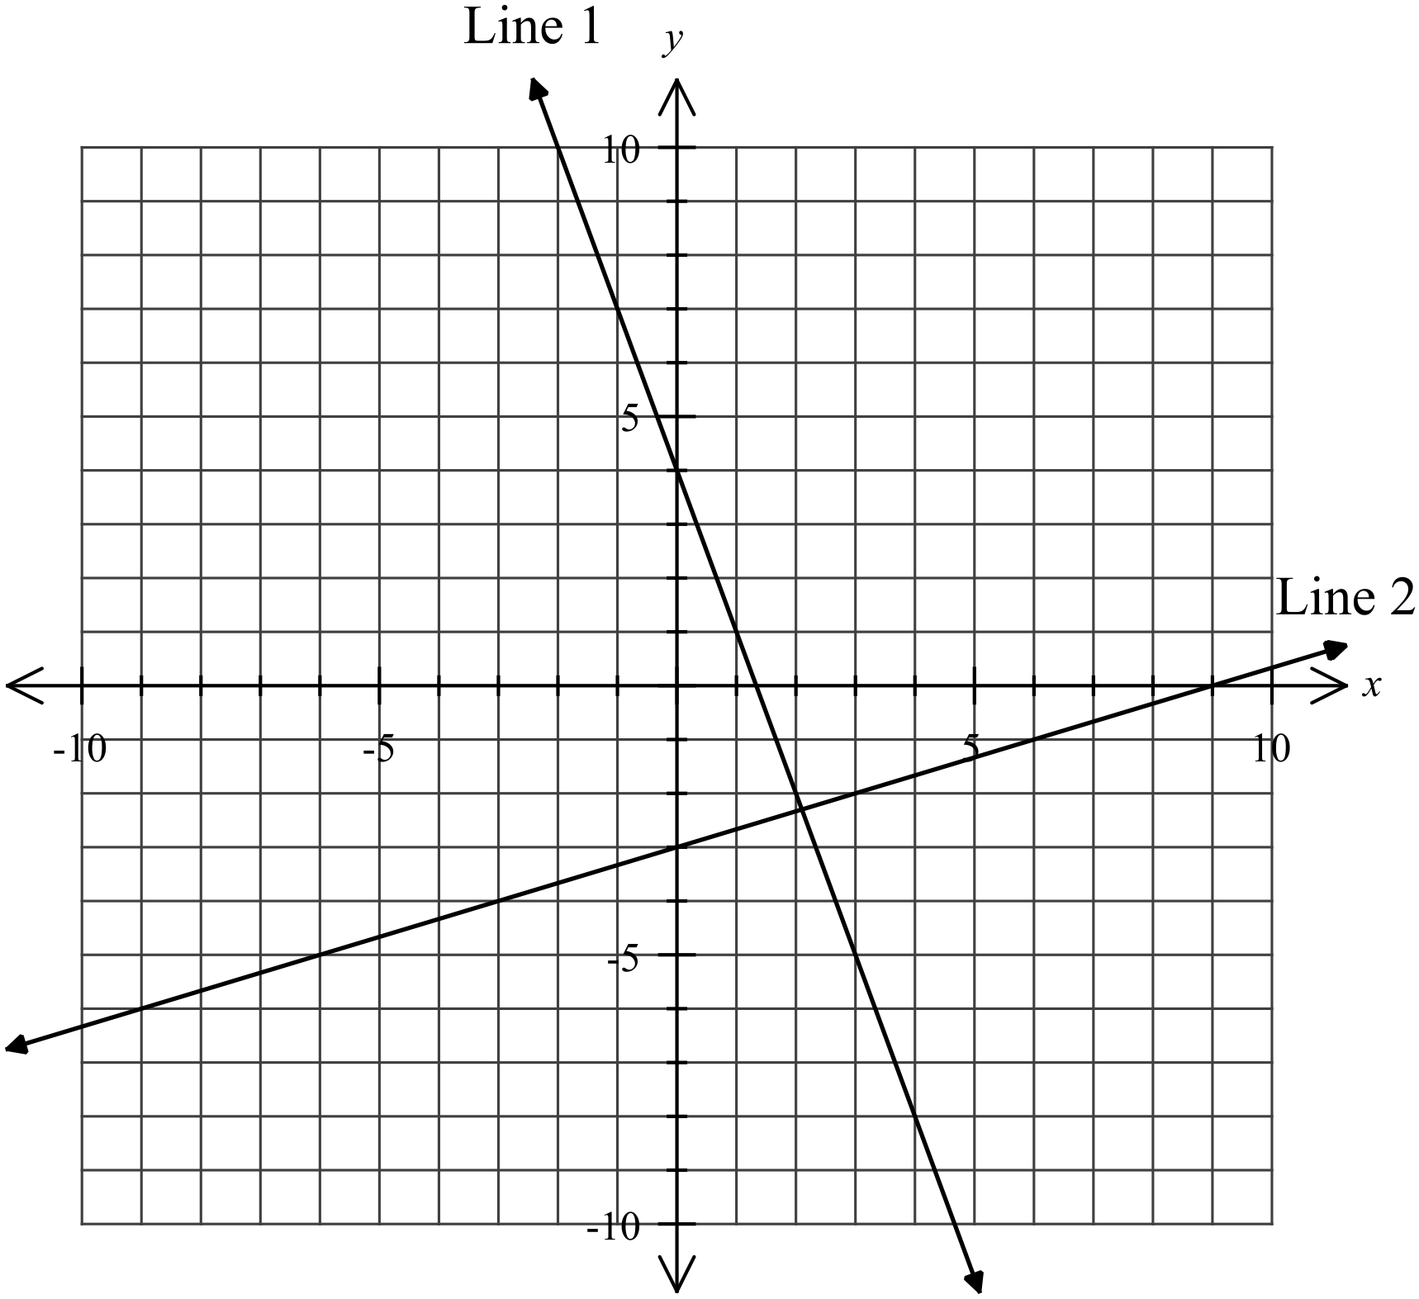 |  | b) | 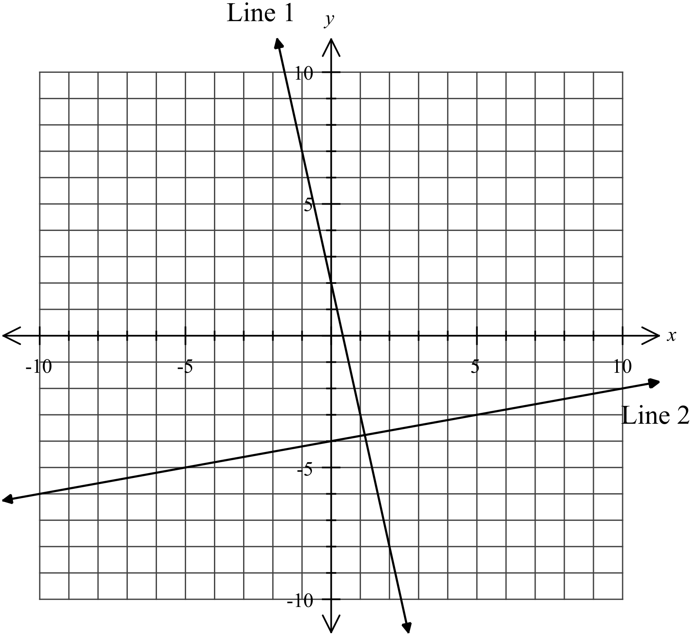
c) | 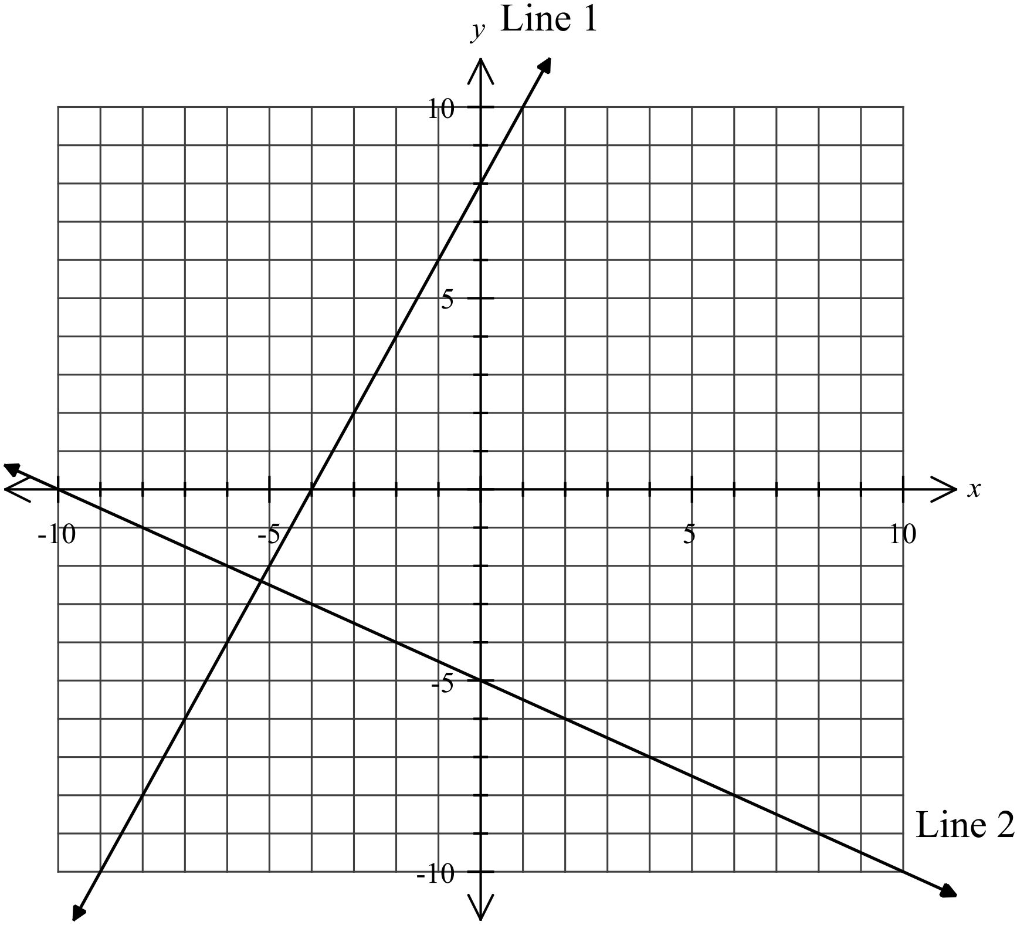 |  | d) | 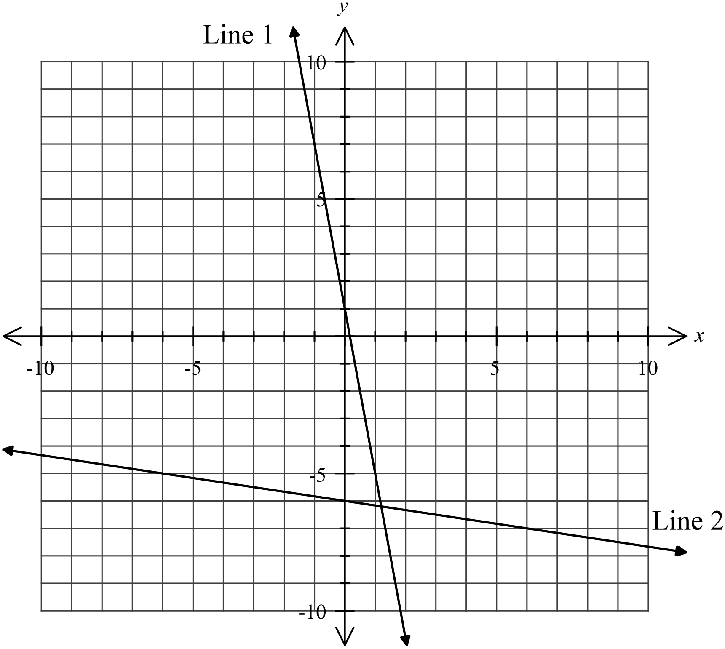
 | Line 1 gradient | Line 2 gradient |  |  | Line 1 gradient × Line 2 gradient
a)
b)
c)
d)

13. | Multiply the two gradients together to fill in the last column of the table.

14. | What pattern do you notice about the gradients?

15. | Write a conjecture (guess) about the relationship between the gradients of perpendicular lines.

16. | Use your conjecture to state whether each pair of linear functions below are perpendicular:
a) | and 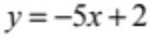
b) | and 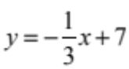
c) | 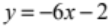 and 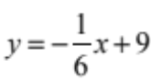
d) | 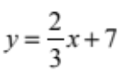 and 